**ASSIGNMENT 4**

1. Write a C program to print **Hello Students** on the screen.

**Ans.** //program to print **Hello Students** on the screen

#include<stdio.h>

#include<conio.h>

Int main()

{

printf(“Hello Students”);

getch();

}

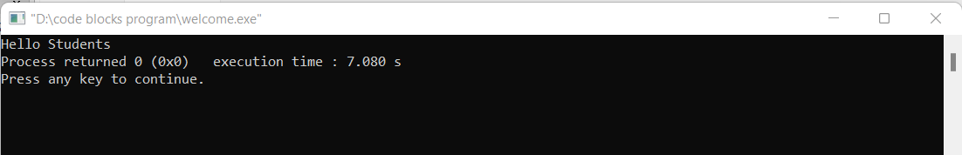

1. Write a C program to print **Hello** on the first line and **Students** in the second line.

**Ans**. //program to print **Hello** on the first line and **Students** in second line

#include<stdio.h>

#include<conio.h>

Int main()

{

printf(“Hello \nStudents”);

getch();

}

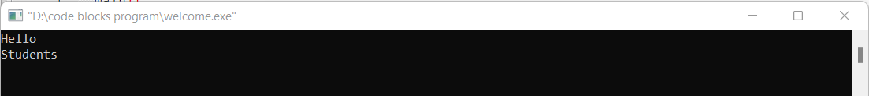

1. Write a C program to print **“MySirG”** on the screen.

**Ans.** //program to print **“MySirG”** on the screen

#include<stdio.h>

#include<conio.h>

Int main()

{

printf(“\“MySirG\””);

getch();

}

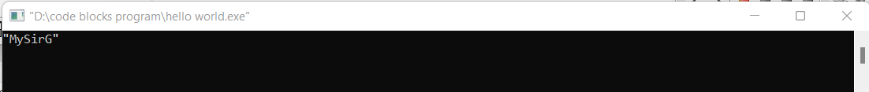

1. Write a C program to print **“Teacher’s Day”** on the screen.

**Ans.** //program to print **“Teacher’s Day”** on the screen

#include<stdio.h>

#include<conio.h>

Int main()

{

printf(“\“Teacher\’s Day\””);

getch();

}



1. Write a program to print **\n** on the screen

**Ans.**  //program to print **“\n”** on the screen

#include<stdio.h>

#include<conio.h>

Int main()

{

printf(“\\n”);

getch();

}

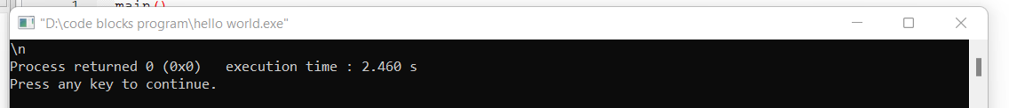

1. Write a program to print **%d** on the screen.

**Ans.** //program to print **“%d”** on the screen

#include<stdio.h>

#include<conio.h>

Int main()

{

printf(“%%d”);

getch();

}

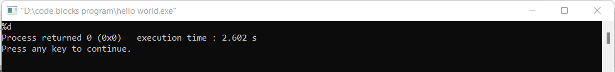

1. Write a C program containing declaration of three variables (of type int, char and float), also assign some values to them and print values of all three variables using single printf().

**Ans.** #include<stdio.h>

#include<conio.h>

Int main()

{

Int x=4;

Char y='a';

Float z=4.2;

printf(“%d %c %f”,x,y,z);

getch();

}

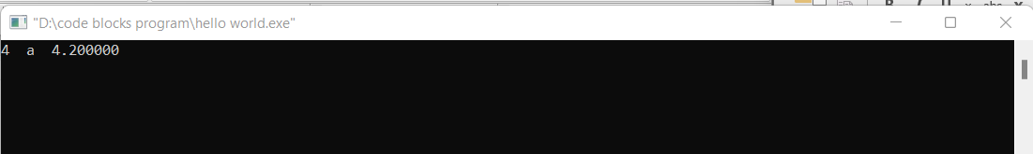

1. Explore following format specifiers on internet - %i, %g, %lf.

**Ans.** %i

In C, **%i** is used to print the value of int which is assign. It is similar if we use in printf statement but it is different when use in scanf() statement.

%g

In C, **%g** displays the output same as the input with a same precision. It is used to print the value of float. It gives the result in either %f (floating point) or %e (scientific notation) and return it as the shorter of the two.

**%lf**

In C, **%lf** is used to print the value of double. Basically %lf is denoted for long and float and it can have precision up to 15 decimals.

1. Write a program to print character stored in a char variable, also print its ASCII code.

**Ans.** //program to print **“%d”** on the screen

#include<stdio.h>

#include<conio.h>

Int main()

{

char y=’A’;

printf(“%c and its ASCII value is %i”,y,y);

getch();

}

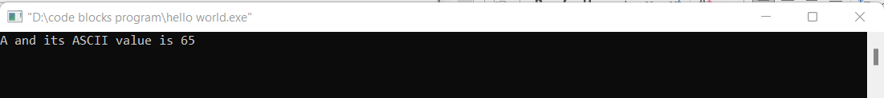

1. How to convert a Decimal number into a Binary number and vice versa.

**Ans.** Decimal to Binary convert:

**Step 1:** Divide the number by 2.

**Step 2:** Get the integer quotient for the next iteration.

**Step 3:** Get the remainder for the binary digit.

**Step 4:** Repeat the steps until the quotient is equal to 0.

Ex: Convert 1310 to binary.

|  |  |  |
| --- | --- | --- |
| **Division** | **Quotient** | **Remainder** |
| 13/2 | 6 | 1 |
| 6/2 | 3 | 0 |
| 3/2 | 1 | 1 |
| ½ | 0 | 1 |

**So,1310 = 11012**

Binary to Decimal convert:

For binary no with n digits

**Dn-1 ……... d3 d2 d1 d0**

The decimal number is equal to the sum of binary digits (dn) times their power of 2 (2n):

**decimal = d0×20 + d1×21 + d2×22 + ...**

Ex: Convert 1110012 to decimal.

|  |  |  |  |  |  |  |
| --- | --- | --- | --- | --- | --- | --- |
| Binary number: | 1 | 1 | 1 | 0 | 0 | 1 |
| Power of 2: | 25 | 24 | 23 | 22 | 21 | 20 |

**So, 1110012 = 1⋅25+1⋅24+1⋅23+0⋅22+0⋅21+1⋅20 = 5710**

Thank You!!